

Mini Project Report - 06

Master of Computer Application
Semester – I

Sub: frontend framework and technologies

Topic: Portfolio Website using CSS Grid & Animations
By
Name: Arbab Suhail
Reg no.: PROV/ASAC/MCA/7/26/082

Faculty Name: Veera Raghav Kathula

Faculty Signature: _______________

Department of Computer Application
Alliance University
Chandapura - Anekal Main Road, Anekal Bengaluru - 562 106

August 2026

INDEX
SL.  NO | NAME  OF  TOPIC | PG  NO
1 | INTRODUCTION | 2
2 | INPUT CODE | 3-10
3 | OUTPUT CODE | 11-14
4 | CONCLUSION | 15

INTRODUCTION
The Student Portfolio is a web-based application developed using HTML and CSS to showcase a student's academic background, skills, projects, and achievements in a single, organized webpage. The main purpose of this project is to present personal and professional information such as qualifications, technical skills, project work, internship experience, achievements, and extracurricular activities in a clean and structured layout. The portfolio includes sections like Home, About, Skills, Qualifications, Projects, Experience, Achievements, and Activities, each designed using HTML for structure and CSS for styling and layout. A fixed navigation bar allows smooth scrolling between sections, making the webpage easy to navigate. This project demonstrates how HTML and CSS can be combined to build a responsive and visually appealing personal portfolio website.

INPUT CODE
<!DOCTYPE html>
<html lang="en">

<head>
<meta charset="UTF-8">
<meta name="viewport" content="width=device-width, initial-scale=1.0">
<title>My Portfolio</title>

<style>
body {
font-family: Arial, sans-serif;
margin: 0;
background-color: lightgray;
}

nav {
background-color: rgb(79, 128, 196);
color: white;
padding: 20px;
display: grid;
grid-template-columns: 1fr 1fr;
}

nav h2 {
margin: 0;
}

nav ul {
display: grid;
grid-template-columns: repeat(4, 1fr);
list-style: none;
margin: 0;
padding: 0;
}

nav a {
color: white;
text-decoration: none;
}

.home {
display: grid;
grid-template-columns: 1fr 1fr;
padding: 80px;
background-color: white;
color: rgb(107, 186, 33);
}

.home h1 {
font-size: 40px;
}

.photo {
display: grid;
place-items: center;
font-size: 100px;
animation: move 2s infinite alternate;
}

.about {
padding: 50px;
text-align: center;
}

.skills {
padding: 50px;
background-color: white;
display: grid;
grid-template-columns: repeat(3, 1fr);
gap: 20px;
}

.skill {
background-color: lightblue;
padding: 30px;
text-align: center;
}

.skill:hover {
transform: scale(1.05);
}

.projects {
padding: 50px;
display: grid;
grid-template-columns: repeat(3, 1fr);
gap: 20px;
}

.project {
background-color: white;
padding: 30px;
}

.project:hover {
transform: scale(1.05);
}

.contact {
background-color: white;
padding: 50px;
text-align: center;
}

@keyframes move {
from {
transform: translateY(0);
}

to {
transform: translateY(20px);
}
}

@media (max-width: 600px) {
nav,
.home {
grid-template-columns: 1fr;
}

nav ul {
grid-template-columns: 1fr;
gap: 10px;
}

.home {
text-align: center;
}

.skills,
.projects {
grid-template-columns: 1fr;
}
}
</style>
</head>

<body>

<nav>
<h2>My Portfolio</h2>

<ul>
<li><a href="#home">Home</a></li>
<li><a href="#about">About</a></li>
<li><a href="#skills">Skills</a></li>
<li><a href="#projects">Projects</a></li>
</ul>
</nav>

<section class="home" id="home">
<div>
<h1>Hii, I am <span>Arbab</span></h1>

<p>
I am an MCA student interested in
web development and programming.
</p>
</div>
</section>

<section class="about" id="about">
<h2>About Me</h2>

<p>
I am currently pursuing MCA.
I like learning HTML, CSS, Python
and new technologies.
</p>
</section>

<section id="skills">
<h2 style="text-align: center;">My Skills</h2>

<div class="skills">

<div class="skill">
<h3>HTML</h3>
<p>Basic Web Development</p>
</div>

<div class="skill">
<h3>CSS</h3>
<p>Web Designing</p>
</div>

<div class="skill">
<h3>Python</h3>
<p>Programming</p>
</div>

</div>
</section>

<section id="projects">
<h2 style="text-align: center;">My Projects</h2>

<div class="projects">

<div class="project">
<h3>Fake Job Detection</h3>
<p>A project to identify fake job postings.</p>
</div>

<div class="project">
<h3>College Event Website</h3>
<p>A responsive website created using HTML and CSS.</p>
</div>

<div class="project">
<h3>Book Recommendation</h3>
<p>An application for recommending books.</p>
</div>

</div>
</section>

<section class="contact">
<h2>Contact Me</h2>

<p>Email: arbab004@gmail.com</p>
<p>Phone: 9305657079</p>
</section>

</body>

</html>

OUTPUT

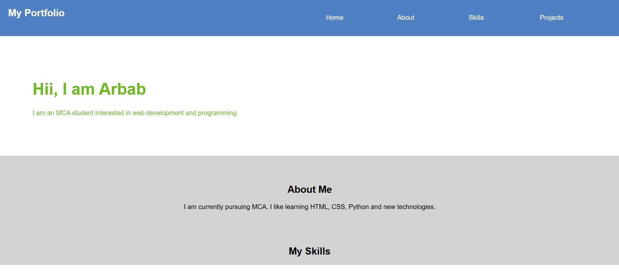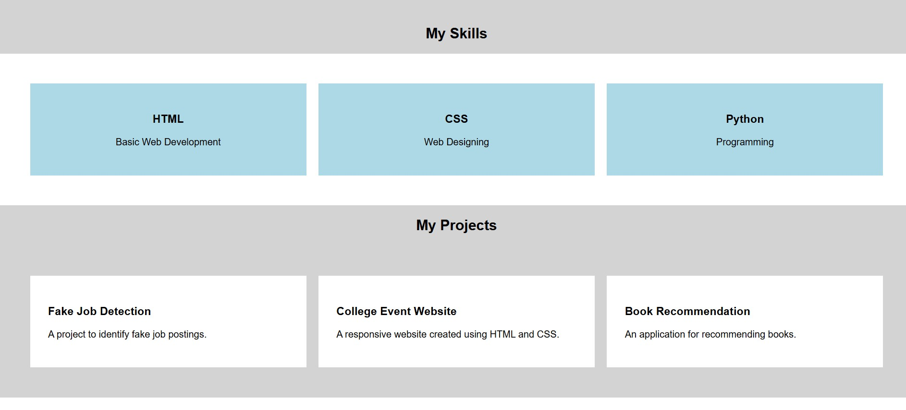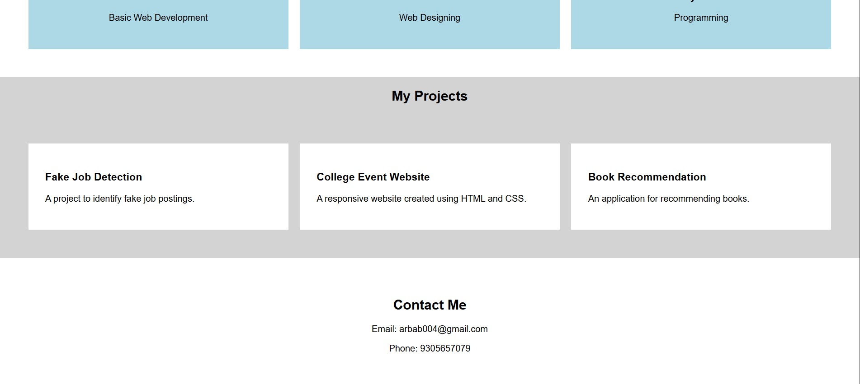

CONCLUSION
The Student Portfolio successfully provides a simple and professional way to present a student's academic background, skills, and achievements on the web. The project uses HTML to create the structure and CSS to design a clean, well-organized interface with smooth navigation between sections. It offers an effective way to showcase qualifications, projects, and extracurricular activities to potential recruiters or academic evaluators. This project also helps in understanding the practical use of HTML and CSS in building a responsive and visually appealing personal website.

